Monographic Lecture in Mathematics  
Spring 2020  
Solution to Lab 1  
Michał Korycki

Link to Github: https://github.com/MatornenSinera/BDA-2ndSemester/tree/master/3rd-semester/Monographic%20Lecture%20In%20Mathematics  
**Dataset:** co2.csv – measurement of CO2 concentration in Earth’s atmosphere.  
Analysis of data beginning from year 1950:

data_mean_global data_mean_nh data_mean_sh

date

1950-01-15 313.597898 314.751334 312.444461

1950-02-15 313.968034 315.402500 312.533568

1950-03-15 314.274349 315.997671 312.551026

1950-04-15 314.468454 316.441488 312.495420

1950-05-15 314.310746 316.134174 312.487318

... ... ... ...

2014-08-15 394.573461 393.376544 395.770379

2014-09-15 395.026810 394.318661 395.734959

2014-10-15 396.668760 397.456653 395.880867

2014-11-15 398.189074 400.321220 396.056929

2014-12-15 399.179692 402.195088 396.164296

[780 rows x 3 columns]

**Exercise 2.** Mean annual CO2 concentrations.

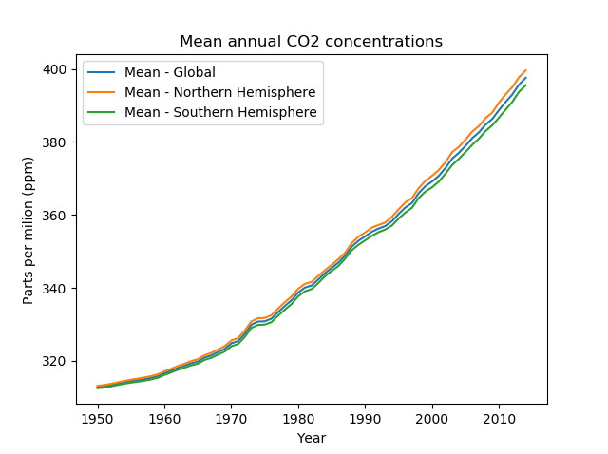

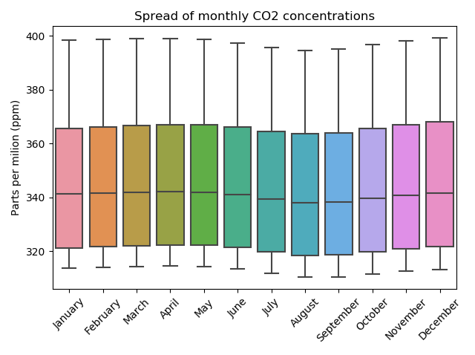**Exercise 3.** Mean annual CO2 concentrations.

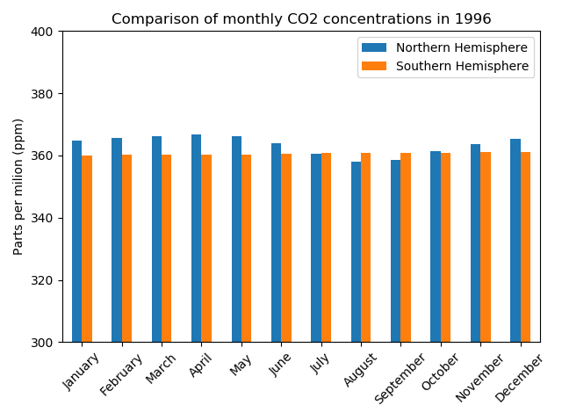**Exercise 4.** Comparison of monthly CO2 concentrations in chosen year.

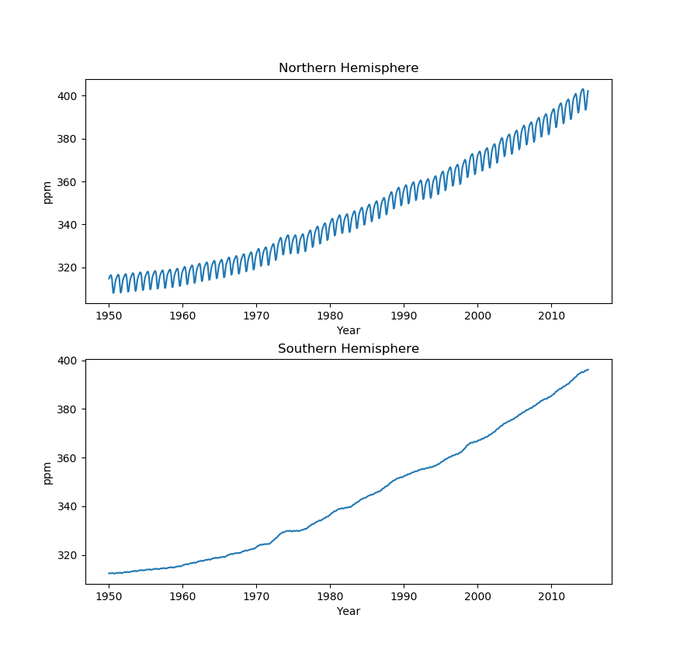**Exercise 5.** Monthly CO2 concentration on both hemispheres.

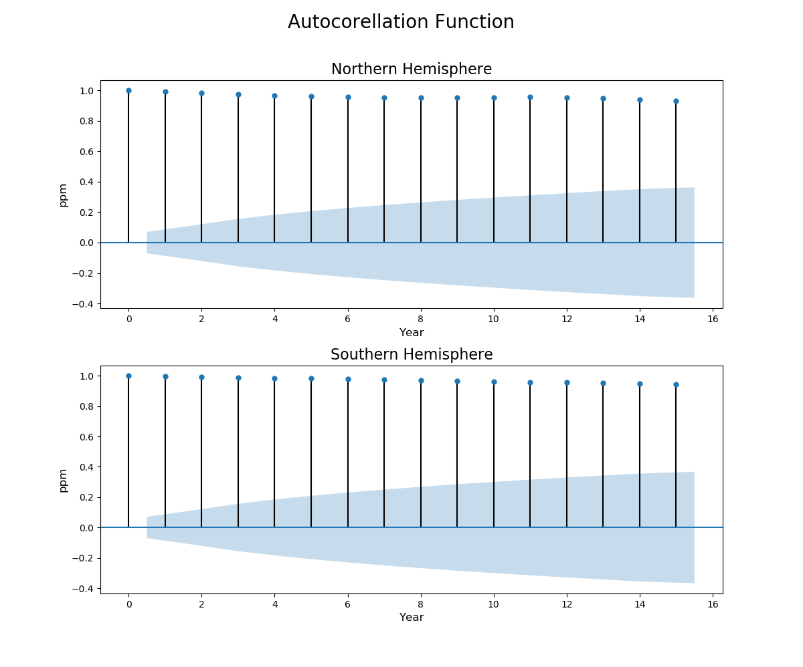**Autocorrelation Function** – lags up to 15.

**Commentary**: Strong correlation of series with itself, which is more visible when describing whole graph with lags up to maximum value (730 entries).  
Both hemispheres show quick, almost linear growth.

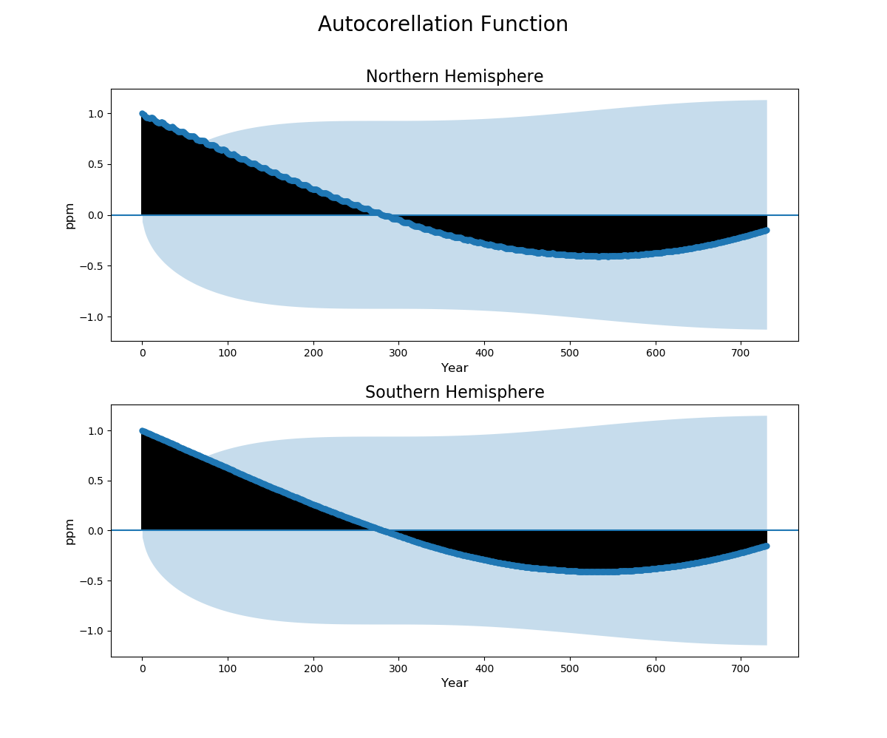**Autocorrelation Function** – lags up to 730.

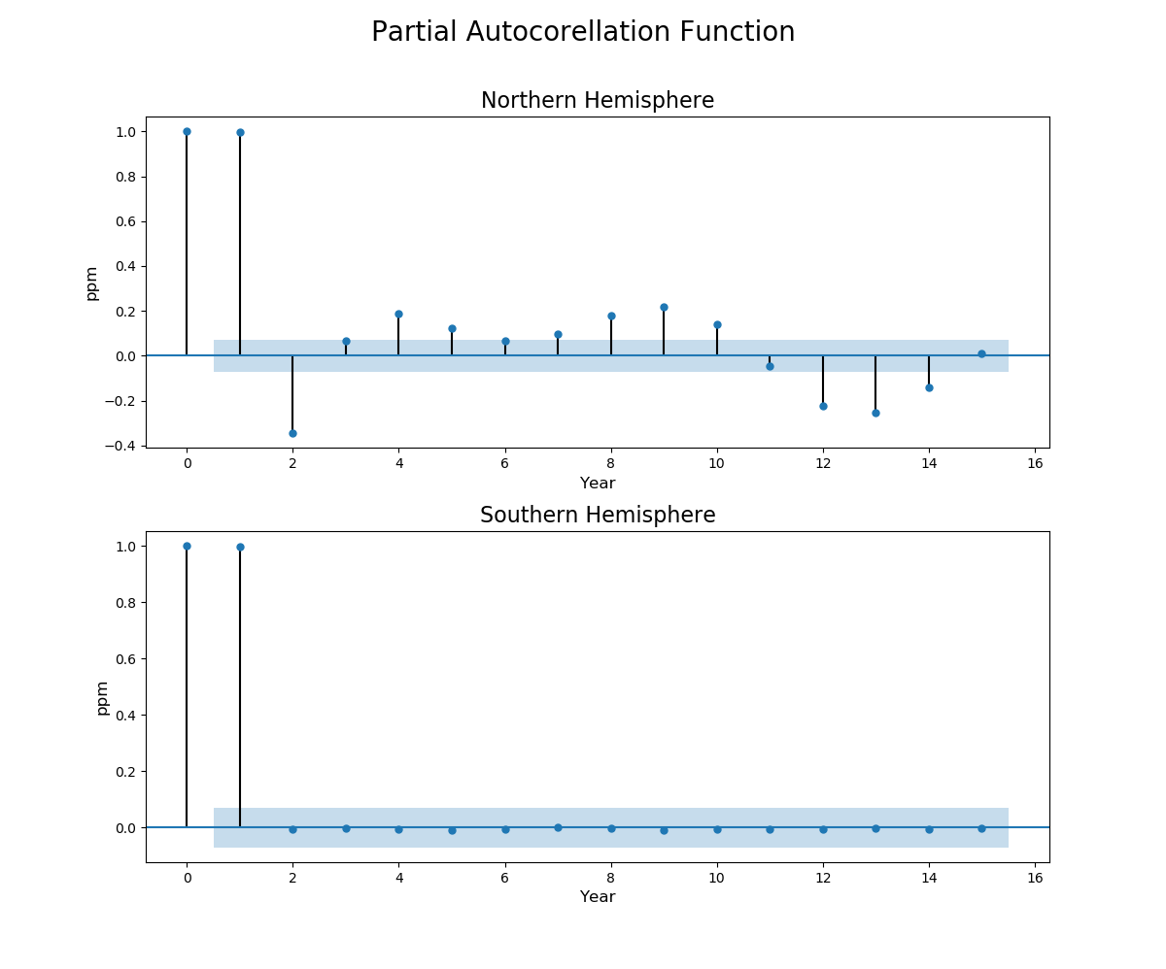**Partial Autocorrelation Function** – lags up to 15

**Commentary**: Upon removal of linear dependence of function on itself, the differences in both hemispheres tend to appear. Southern Hemisphere depicts almost not existent change month to month. In Northern Hemisphere CO2 concentration diverges on monthly basis, with visible time periods equal to one year.

**Exercise 6.** Seasonal decomposition – Additive Model and Multiplicative Model

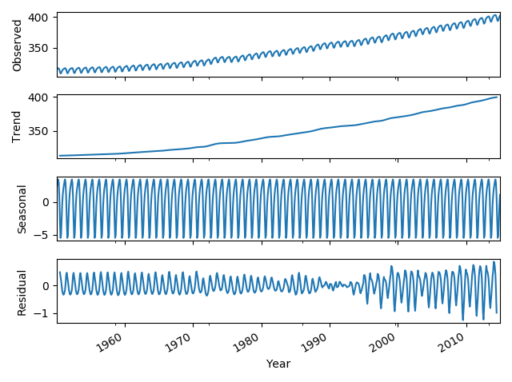**Additive Model – Northern Hemisphere**

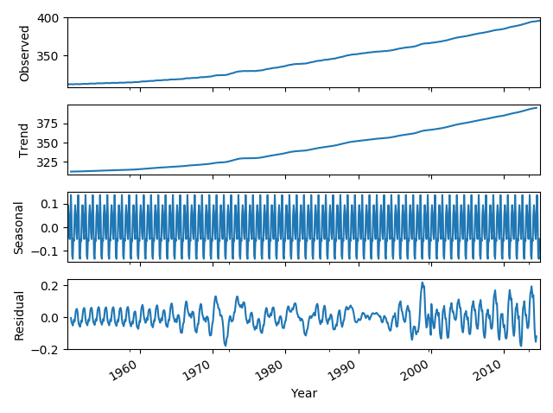**Additive Model – Southern Hemisphere**

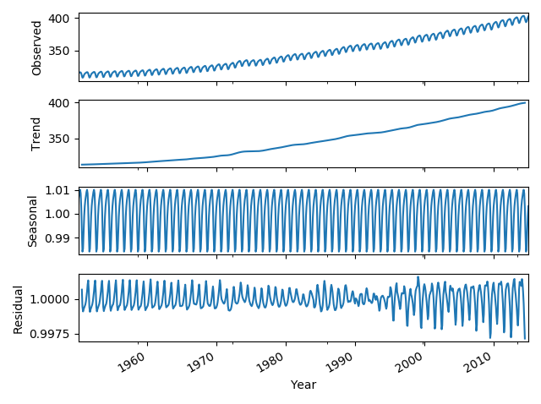**Multiplicative Model – Northern Hemisphere**

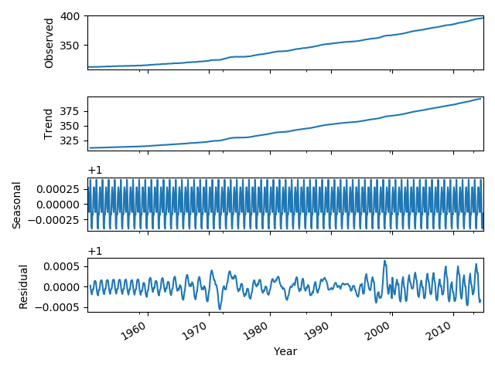**Multiplicative Model – Southern Hemisphere**

**Commentary:** We are able to distinguish a visible trend in Northern Hemispheres that has a similar shape to a trend shown in Southern Hemisphere, but also consists of visible seasonal and residual components, which in comparison are nearly nonexistent in analysis derived from Southern Hemisphere.

There are no major differences between additive and multiplicative models in both examples, except for values of seasonal and residual components, which have always higher altitudes in Northern Hemispheres example.